2-02129
News Release Communiqué

INDUSTRIAL TRAINING PROGRAM TAKES A MADE-IN-THE-NORTH APPROACH

YELLOWKNIFE (April 8, 2002) - A made-in-the-north approach to job training will get support under the Department of Indian Affairs and Northern Development’s Resource Partnerships Program. The Honourable Ethel Blondin-Andrew, MP for the Western Arctic, on behalf of the Honourable Robert D. Nault, Minister of Indian Affairs and Northern Development (DIAND) announced that the NWT Mine Training Committee will receive an investment of $212,500 to develop training modules and curriculum for Phase II of the Industrial Training Program - the Apprenticeship Training Program.

“It’s encouraging that more and more Aboriginal Northerners are finding jobs in the mining industry, but it is essential that they have access to jobs at all levels,” said Ethel Blondin-Andrew. “The Apprenticeship Training Program will provide Aboriginal people with training at higher levels in the mines, which can lead to advancement through continuing training and development.”

A total of 125 northerners took part in the Construction Helper Training Program, which was the first phase of the Industrial Training Program. Phase I introduced participants to a wide range of occupations within the mining industry. Entry-level training in 20 occupations, as well as job and life skills was provided. DIAND supported Phase I with a contribution of $91,000.

Twenty graduates from Phase I will be selected for the Apprenticeship Training Program, which will provide in-depth theoretical and skills training that can help participants reach journeyman status. Graduates will be qualified for long-term, sustainable jobs that will lead to increased income levels and security. Graduates of the program will earn an average of $60,000 per year much of which will be reinvested in their home communities creating a multiplier effect on the local economy.

. . . /2

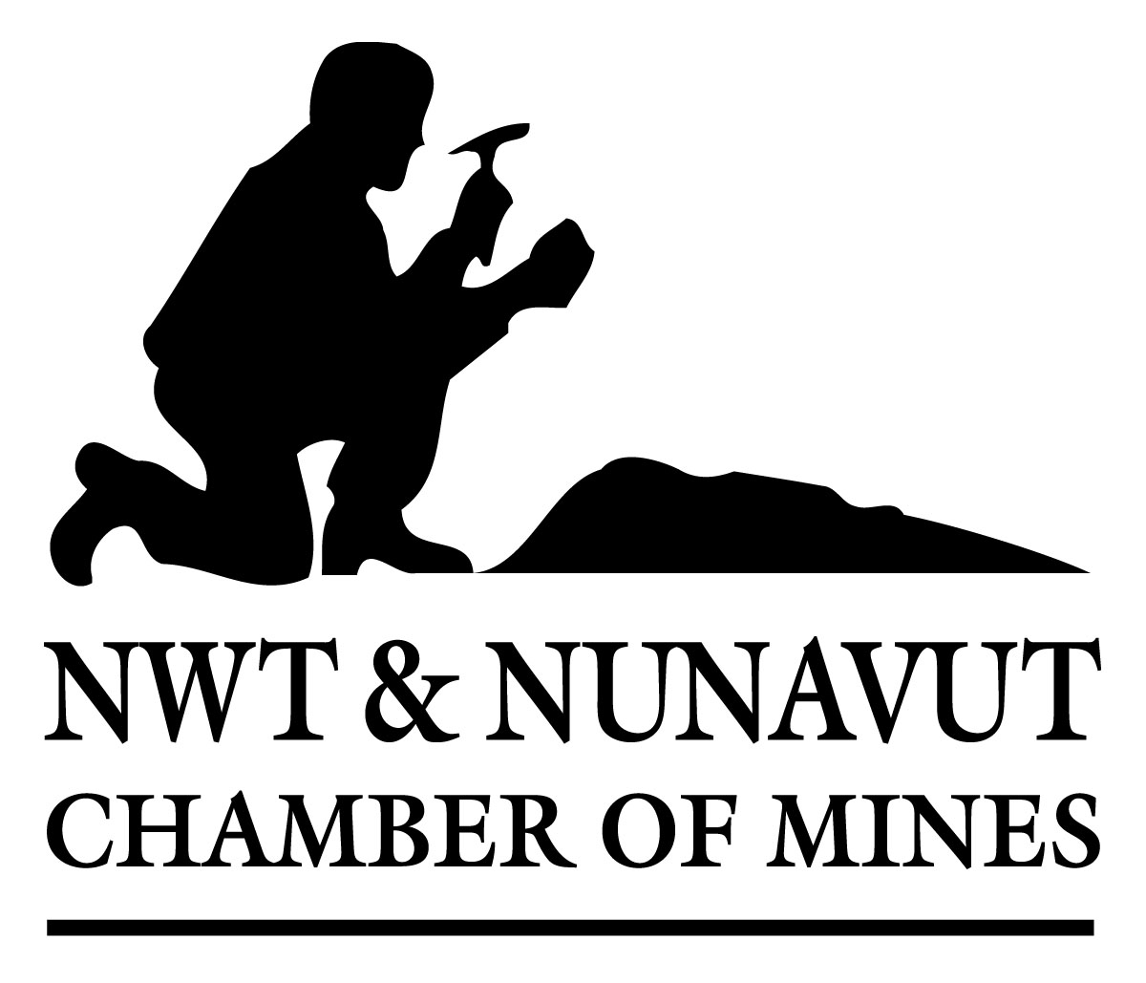

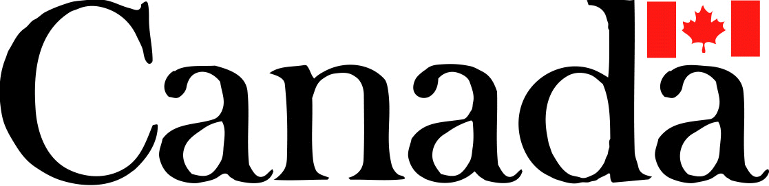

- 2 -

The Apprenticeship Training Program is a unique partnership between the Mine Training Committee, the NWT Department of Education, Culture and Employment, the NWT Department of Resources, Wildlife and Economic Development, and Diavik Diamond Mines Inc., the Deton Cho Corporation and PTI/Travco Ltd.

“The mining industry is very interested in ensuring more and more Aboriginal Northerners are trained and ready to take on a variety of jobs, especially in the trades,” said Darrell Beaulieu, Co-Chair of the NWT Mine Training Committee. “We are pleased to make this investment in Northerners and the NWT economy.”

As part of its contract with Diavik Diamond Mines Inc., PTI/Travco Ltd. will provide on-the-job and academic training in specified trades to program participants at the Nisku, Alberta Plant and the Diavik Diamond Mine Site.

Special training modules and curriculum are being developed to meet the unique training method, as well as the academic and skill level of the participants. It will take a significant commitment on the part of all partners to ensure that the training meets the exacting standards of journeyman level industrial training, but is still accessible to the academic and literacy levels of participants.

The total cost of the program is $940,000. Funding is also being contributed by: Diavik Diamond Mines Inc. ($337,500); PTI/Travco. Ltd. ($140,000); the NWT Department of Education, Culture and Employment ($100,000); Department of Resources, Wildlife and Economic Development, GNWT ($150,000).

The NWT Mine Training Committee was formed by the Minister of Education, Culture and Employment, Government of the Northwest Territories to respond to the growing need for a skilled northern work force in the northern mining industry. The Committee is a broad consortium of industry, Aboriginal groups, federal and territorial governments and Aurora College.

-30-

This release is also available on the Internet at http://www.inac.gc.ca.

For further information, contact:

Lorne Tricoteux  Associate Regional Director General  Department of Indian Affairs and  Northern Development  Phone: (867) 669-2501 | Dan O’Neill  NWT Mine Training Committee  P.O Box 2818  Yellowknife, NT  Phone: (867) 920-6152

